OUTPUT OF THE FOLLOWING PROBLEM:

If number is palindrome:

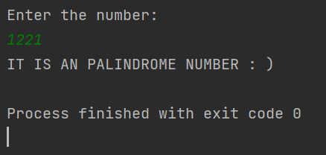

If number is not an palindrome:

